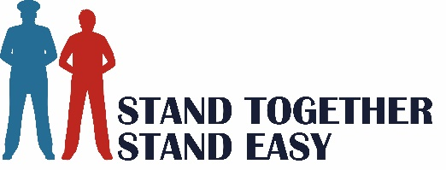 Equality, Diversity & Inclusion Policy
________________________________________________________________

Aims
Stand Together, Stand Easy CIC believes matters of equality, diversity and inclusion should not be separate from any aspect of the company’s form or function but are values and actions that extend throughout our organisation, guiding and progressing our operations, practice, and reach. We strive to ensure contemporary cultural competency for the empowerment of all who participate in our initiatives, go through recruitment, work with us, volunteer or connect to Stand Together Stand Easy.

The purpose of the Equality, Diversity & Inclusion Policy is to set out clearly and fully the positive action Stand Together Stand Easy intends to take to combat direct and indirect discrimination or unconscious bias in the organisation, the services it provides and in its partnerships with other bodies. In adopting this Equality, Diversity & Inclusion Policy, we are also making an unequivocal commitment to implementing it, to ensure that equal opportunity is a reality.

Inclusion, Discrimination & Respect
Stand Together Stand Easy CIC recognises that in our society power is not held equally and that groups and individuals have been and continue to be discriminated against on many grounds. Where direct or indirect discrimination occurs, it is both morally and legally unacceptable.
We are not only inclusive but anti-discriminatory. We will speak up to support and protect those at risk from discrimination, harassment and abuse, whether from age, disability, gender reassignment, marriage or civil partnership, pregnancy or maternity, race, religion or belief, sex, or sexual orientation, class, background or any other characteristic. We will ensure everyone is treated with the utmost respect and welcomed. Offensive and inflammatory remarks or behaviour are not acceptable and will be addressed through our Code of Practice and Complaints Procedure.

Diversity
Stand Together Stand Easy embraces diversity as of infinite benefit, is open to and actively seeks new ideas, and particularly prioritises opportunities for our projects, individuals and our organisation to share cultural heritage with one another.

Accessibility
We are committed to ensuring fully accessible physical venues and digital environments for anyone who wants to connect with or is involved with Stand Together, Stand Easy CIC. Being accessible to all means we will do all that we can to make accessing us and our events or reaching out to others as comfortable and enjoyable as possible for everyone. We can be contacted to discuss any specific requirements that need to be in place to support people with additional needs, our well-informed staff are on hand to help.

Date of Issue: September 2022
Review Date: September 2023

